How to convert Alloy Tabs into Liferay 6.2 advance web content

Visit Alloy UI Tab page to understand the functionality about AUI tab plugin - <http://alloyui.com/examples/tabview/>

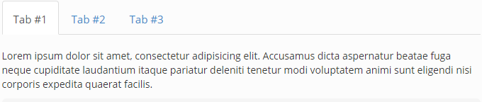

# **STEP1**: Create Web Content

In DockBar click on **Admin** > **Content** – in left nav click on ‘**Web content**’

Click on **Add** > **Basic Web content**

# **STEP 2**: Add/Create structure

Create structure add fields to get tabs input.

Add filed

Tab ID – as textbox,

Tab Name – textbox

Tab Content – HtmlTextbox

Save the structure

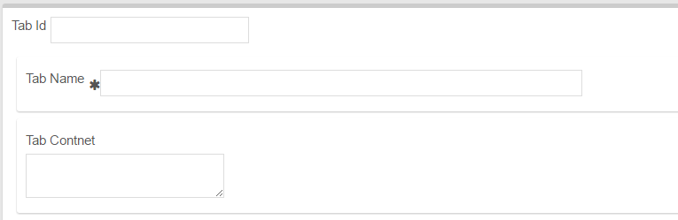

Code:

# **STEP 3**: Add/Create Template

Select Velocity template

Set variables

## SET DEBUG STATE  
#set($debug = "false ")  
  
#set($tabCnt = 0)  
#if (!$tabs.getSiblings().isEmpty())

Add AUI tab container  
<div id="tabWebContent">  
 <ul class="nav nav-tabs">

Add loop to get no od tabs  
#foreach ($tab in $tabs.getSiblings())  
 #set($tabCnt = $tabCnt + 1)  
 #set($tabId = "tab-" + $tabCnt)   
 #set($uiId = "ui-id-" + $tabCnt)

Check null value and Add tab name template  
#if($tab.getData() != "null")  
 <li><a href="#$tabId">$tab.tabName.getData()</a></li>  
#end

End first loop  
#end

End UL  
</ul>

Add tab content container  
<div class="tab-content">

Add tabs content template   
 #set($tabCnt = 0)  
 #foreach ($tab in $tabs.getSiblings())  
 #set($tabCnt = $tabCnt + 1)  
 #set($tabId = "tab-" + $tabCnt)   
 #set($uiId = "ui-id-" + $tabCnt)   
 #if($tab.getData() != "null")  
 <div id="#$tabId" class="tab-pane">  
 <p>$tab.tab_contnet.getData()</p>  
 </div>  
 #end  
 #end

Close tab content container   
</div>

Close tab main container   
</div>

End first if condition   
#end

# STEP4 – **Add AUI/YUI script**

Add script within structure after the all the code

<script>  
YUI().use(  
 'aui-tabview',  
 **function**(Y) **{**  
 **new** Y.TabView(  
 **{**  
 srcNode**:** '#tabWebContent'  
 **}**  
 ).render();  
 **}**  
);  
  
</script>

Save the template

# STEP5 – Add content and publish the web content.



**Structure code (.xml):**

<root available-locales="en_US" default-locale="en_US">

<dynamic-element dataType="string" indexType="" localizable="true" name="tabs" readOnly="false" repeatable="true" required="false" showLabel="true" type="text" width="small">

<dynamic-element dataType="string" indexType="" localizable="true" name="tabName" readOnly="false" repeatable="false" required="true" showLabel="true" type="text" width="large">

<meta-data locale="en_US">

<entry name="label">

<![CDATA[Tab Name]]>

</entry>

<entry name="predefinedValue">

<![CDATA[]]>

</entry>

<entry name="tip">

<![CDATA[]]>

</entry>

</meta-data>

</dynamic-element>

<dynamic-element dataType="html" fieldNamespace="ddm" indexType="keyword" localizable="true" name="tab_contnet" readOnly="false" repeatable="false" required="false" showLabel="true" type="ddm-text-html" width="small">

<meta-data locale="en_US">

<entry name="label">

<![CDATA[Tab Contnet]]>

</entry>

<entry name="predefinedValue">

<![CDATA[]]>

</entry>

<entry name="tip">

<![CDATA[]]>

</entry>

</meta-data>

</dynamic-element>

<meta-data locale="en_US">

<entry name="label">

<![CDATA[Tab Id]]>

</entry>

<entry name="predefinedValue">

<![CDATA[]]>

</entry>

<entry name="tip">

<![CDATA[]]>

</entry>

</meta-data>

</dynamic-element>

</root>

**Template Code (.vm):**

## SET DEBUG STATE  
#set($debug = "false ")  
  
#set($tabCnt = 0)  
#if (!$tabs.getSiblings().isEmpty())  
  
<div id="tabWebContent">  
  
 <ul class="nav nav-tabs">  
 #foreach ($tab in $tabs.getSiblings())  
 #set($tabCnt = $tabCnt + 1)  
 #set($tabId = "tab-" + $tabCnt)   
 #set($uiId = "ui-id-" + $tabCnt)   
 #if($debug == "true")***&nbsp***;***&nbsp***;***&nbsp***;***&nbsp***;<b>\$tabId</b> = $tabId</br>#end   
 #if($debug == "true")***&nbsp***;***&nbsp***;***&nbsp***;***&nbsp***;<b>\$tab.tabName.getData()</b> = $tab.tabName.getData()</br>#end   
 #if($debug == "true")***&nbsp***;***&nbsp***;<b>\$cnt</b> = $cnt</br>#end   
 #if($debug == "true")***&nbsp***;***&nbsp***;<b>\$isActive</b> = $isActive</br>#end   
 #if($debug == "true")***&nbsp***;***&nbsp***;<b>\$activeClasses</b> = $activeClasses</br>#end   
 #if($tab.getData() != "null")  
 <li><a href="#$tabId">$tab.tabName.getData()</a></li>  
 #end   
 #end   
   
 </ul>  
  
 <div class="tab-content">  
 #set($tabCnt = 0)  
 #foreach ($tab in $tabs.getSiblings())  
 #set($tabCnt = $tabCnt + 1)  
 #set($tabId = "tab-" + $tabCnt)   
 #set($uiId = "ui-id-" + $tabCnt)   
 #if($tab.getData() != "null")  
 <div id="#$tabId" class="tab-pane">  
 <p>$tab.tab_contnet.getData()</p>  
 </div>  
 #end  
 #end  
  
 </div>  
  
</div>  
#end  
  
<script>  
YUI().use(  
 'aui-tabview',  
 **function**(Y) **{**  
 **new** Y.TabView(  
 **{**  
 srcNode**:** '#tabWebContent'  
 **}**  
 ).render();  
 **}**  
);  
  
</script>